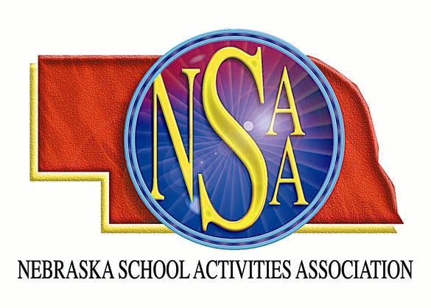
MOA/ENOA/NSAA FOOTBALL
OFFICIALS’ CLINICS &
RULES MEETINGS

The Midwest Officials Association, Eastern Nebraska Officials Association and Nebraska School Activities Association will sponsor football officiating clinics at Buel Stadium in Millard and Grand Island High School. There will be schools conducting an intra-squad scrimmage in the morning. Officials should come prepared to officiate. Knickers and socks are not required. Attendees will be divided into two groups for the morning sessions. Each group will have field time and classroom time. We will make every effort to accommodate crews.

Saturday, August 16, 2008

Check In: 7:30 am – 8:00 am
Position Meeting: 8:00 am – 9:00 am
Scrimmage I/Classroom I: 9:00 am – 10:30 am
Scrimmage II/Classroom II: 11:00 am – 12:30 pm
Lunch (Provided): 12:30 pm – 1:00 pm
NSAA Rules Meeting: 1:00 pm – 2:00 pm
Film (optional): 2:00 pm – 3:00 pm

$ 30.00 Non-Refundable Registration Fee

Complete the registration form with all the necessary information and enclose payment of $30.00.
The fee is non-refundable. Return by August 6, 2008 SPACE IS LIMITED!

_________________________________________________________________________________________________

Name:_____________________________________ Address:___________________________________

City, State, Zip:______________________________ Telephone #:________________________________

E-mail:_____________________________________ Position:____________________________________

Check for clinic attending: _____Millard _____Grand Island

MAIL TO: NSAA
PO Box 85448


Lincoln, NE 68501-5448

